**Experiment No : 3**

**AIM**

Familiarization of LINUX Commands.

**CO2**

Perform system administration task.

**Procedure**

1. pwd

print the working directory

$ pwd

Output

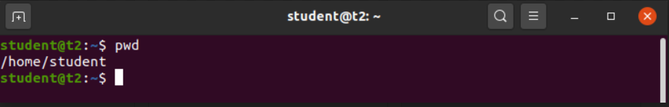

1. ls

to view the contents of a directory

$ ls

Output

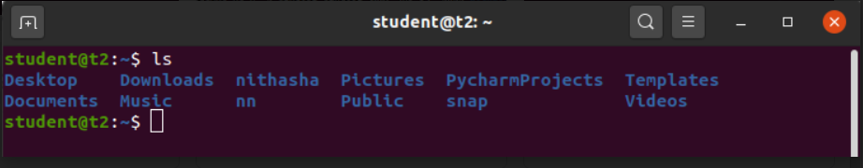

2.1) ls –R

List the contents of the subdirectories

$ls –R

Output

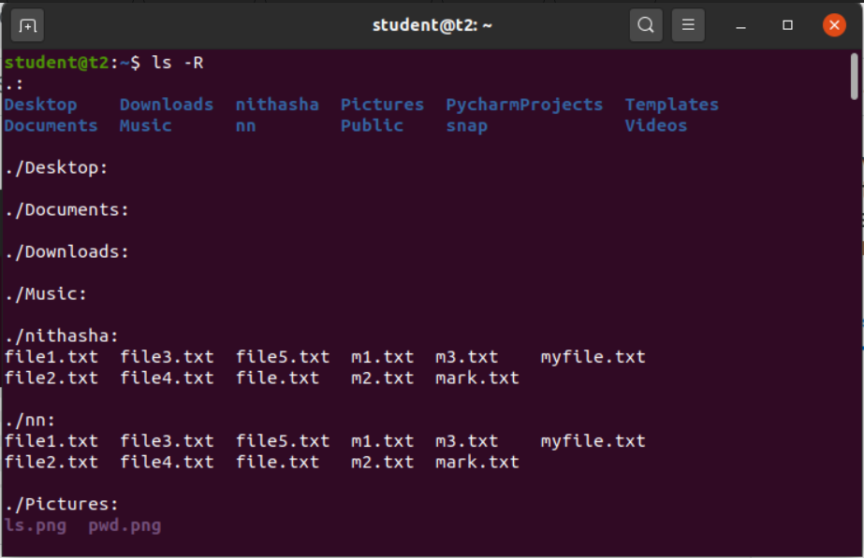

2.2) ls –l

Long listing of contents of directory

$ls –l

Output

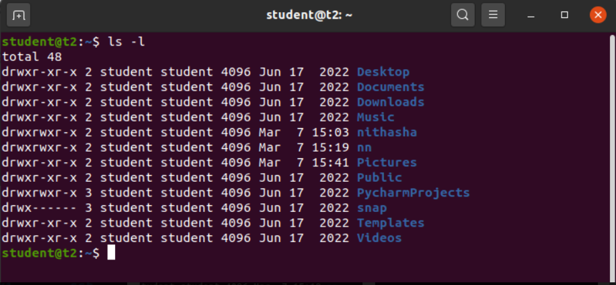

2.3) ls –a

Lists the hidden files in the directory

$ls -a

Output

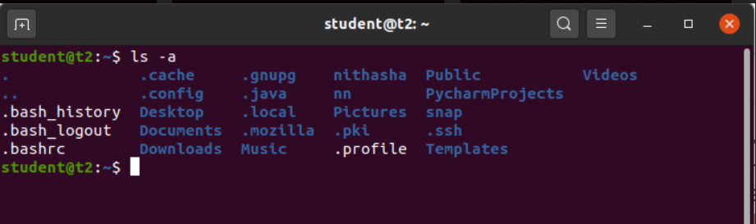

2.4) ls –al

Lists the directories & files with detailed information about owner, file size , permissions etc.

$ls –al

Output

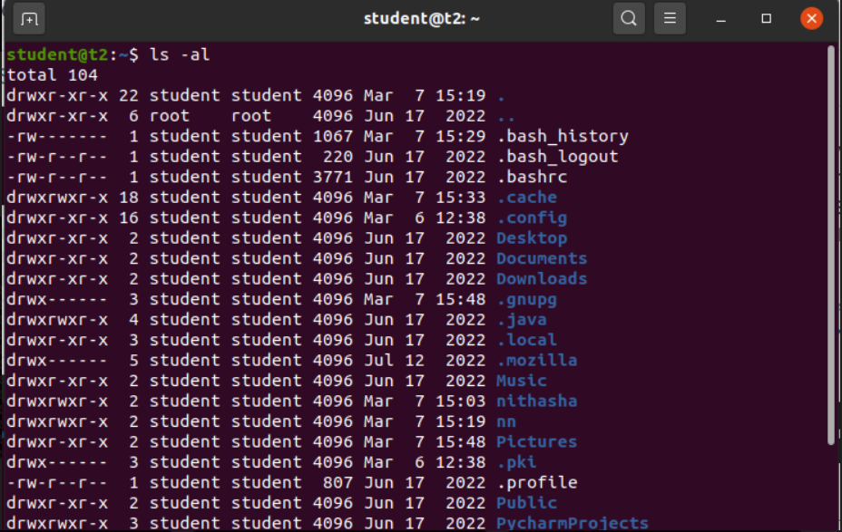

2.5) ls –t

Lists the contents in the order of last modified

$ls –t

Output

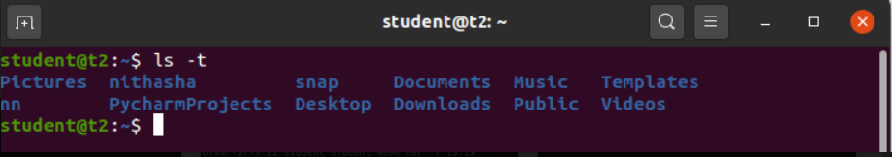

2.6) ls –r

To reverse the natural sorting order of the last modified date of directory

$ls –r

Output

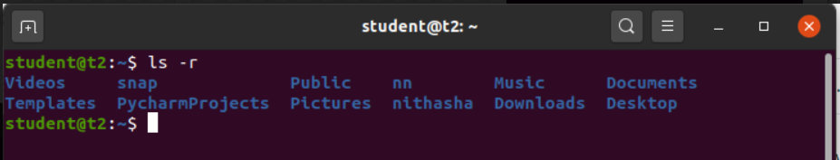

1. history

$ history

Output

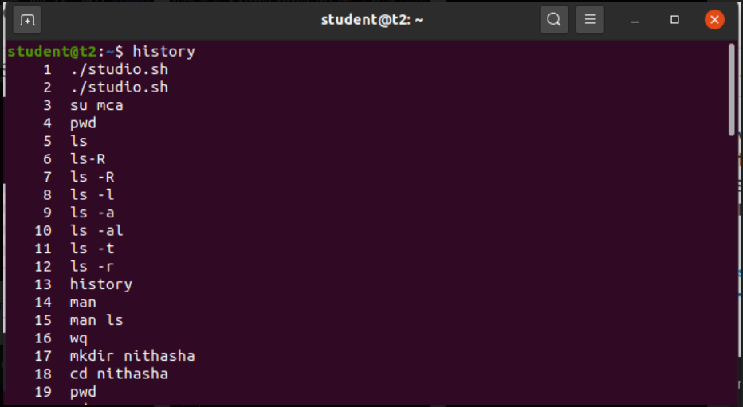

1. man

To learn and understand about different commands

$man ls

Output

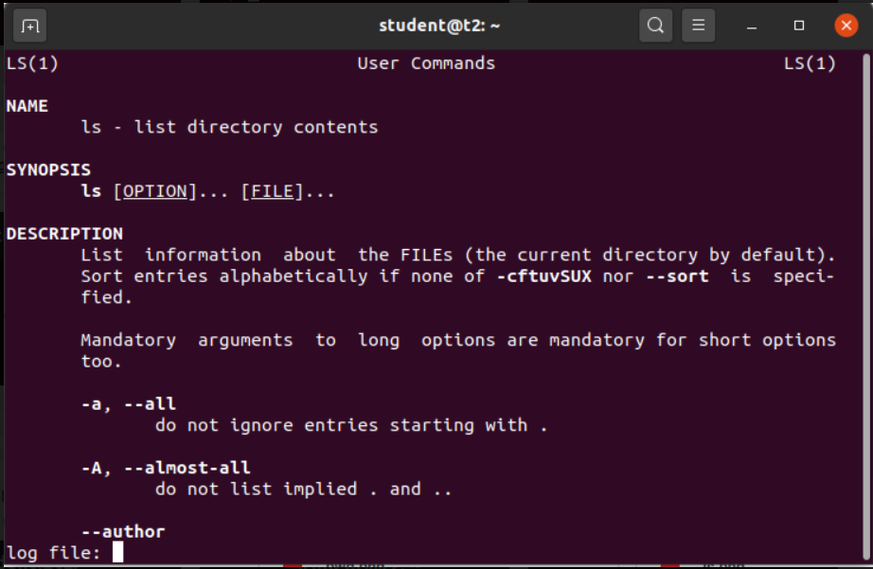

1. mkdir

Create a new directory

$mkdir sample

Output

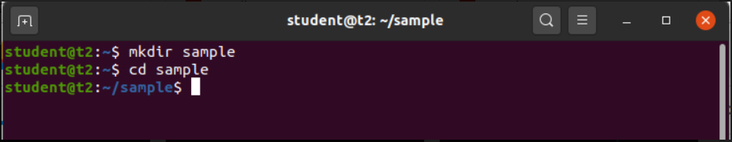

1. cd

Change directory

$cd sample

Output



6.1) cd ..

To change directory to the previous one

$cd ..

Output



1. rmdir

To remove a directory

$rmdir sample

Output



1. touch

To create an empty file

$touch file.txt

Output

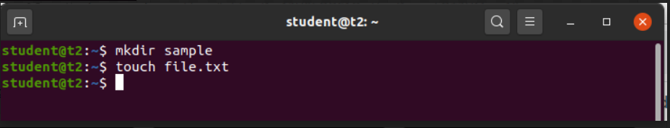

1. cat

To add content to the file

$cat > file.txt

Output

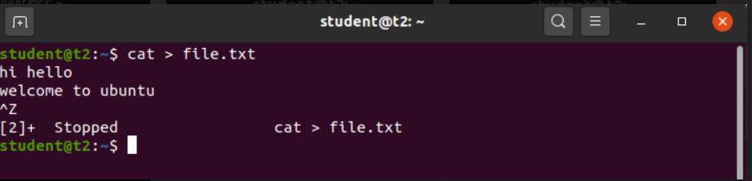

9.1) cat filename

To view the file content

$cat file.txt

Output



9.2) cat >> filename

Append content to the existing file

$cat >> file2.txt

Output

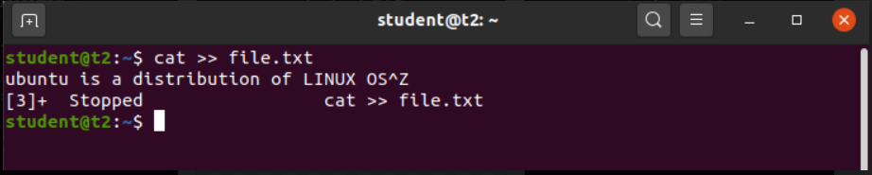

9.3) cat –n filename

To display content with file numbers

$cat –n file.txt

Output

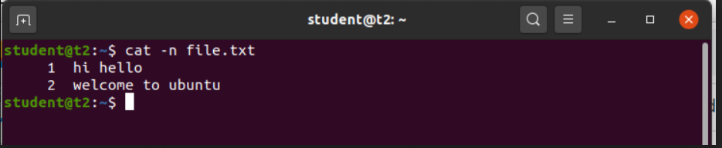

9.4) cat –b filename

Omits line numbers for blank space

$cat –b file.txt

Output

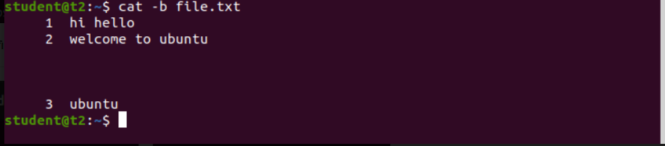

9.5) cat filename1 > filename2

To copy content from filename1 to filename2

$cat file4.txt

Output

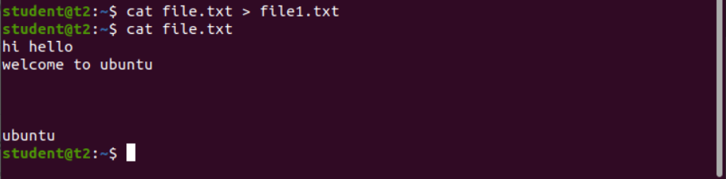

9.6) cat filename1 filename2 > filename3

To combine the contents of 1st 2 files to the 3rd file

$cat file.txt file1.txt > file2.txt

Output

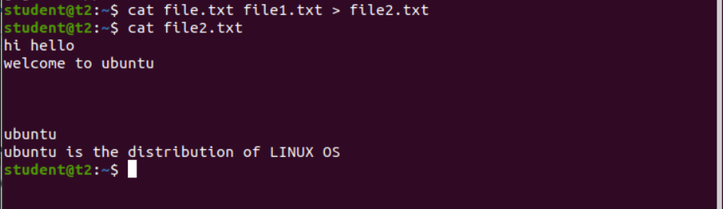

9.7) cat filename | tr a-z A-Z > filename

To change the contents of 1st file and save it into the 2nd file as uppercase

$cat –e file.txt

Output

